

IMPLEMENTATION OF EC2 TERMINATION PROTECTION AND INSTANCE RESIZING IN AMAZON WEB SERVICES (AWS)
A Comprehensive Cloud Computing Project Report
Bachelor of Science in Computer Science
BY: LWANYAGA ERIC SENTAMU
Reg No: 24/U/16566/PSA
STUDENT No: 2400716566
PRESENTED TO: MR MAGOMBE YASIN

Abstract
This report presents a detailed study and implementation of Amazon EC2 Termination Protection and Instance Resizing. The project demonstrates how cloud administrators can secure virtual machines from accidental deletion and dynamically adjust computing resources based on workload requirements. The practical implementation was conducted using AWS EC2 services. The study explores theoretical foundations, implementation procedures, results, benefits, challenges, and recommendations. The findings indicate that termination protection enhances infrastructure reliability while instance resizing improves scalability and cost efficiency.

Table of Contents
1. Abstract
2. Introduction
3. Background of Study
4. Problem Statement
5. Objectives
6. Literature Review
7. Methodology
8. System Architecture
9. Implementation Procedures
10. Results and Discussion
11. Cost Analysis
12. Risk Assessment
13. Challenges Encountered
14. Conclusion
15. Recommendations
16. References
17. Appendices

Chapter 1: Introduction
Cloud computing is a model for delivering computing services over the internet on a pay-as-you-go basis. Organizations increasingly use cloud platforms to host applications, store data, and deploy services. AWS is among the world's leading cloud providers and offers scalable, reliable, and secure cloud services. Amazon Elastic Compute Cloud (EC2) provides virtual servers that can be provisioned and managed on demand. This project focuses on two critical EC2 administrative features: Termination Protection and Instance Resizing.

Background of Study
Cloud environments host mission-critical applications whose availability and reliability are essential. Administrators require mechanisms to prevent accidental deletion of resources while maintaining flexibility to adjust resource capacity. AWS provides termination protection and resizing features to address these requirements.

Problem Statement
Accidental deletion of cloud instances can result in service disruption, data loss, and financial consequences. Similarly, incorrect resource allocation can lead to poor performance or excessive operational costs. Organizations need reliable mechanisms to protect and optimize cloud resources.

Objectives
General Objective:
To implement and evaluate EC2 Termination Protection and Instance Resizing in AWS.
Specific Objectives:
• Launch and configure an EC2 instance.
• Enable and test termination protection.
• Disable termination protection when necessary.
• Resize an EC2 instance.
• Verify successful operation after resizing.
• Evaluate the benefits of these cloud management features.

Chapter 2: Literature Review
Amazon EC2 allows users to rent virtual computing environments. According to AWS documentation, EC2 provides scalable computing resources that can be launched, stopped, resized, and terminated on demand. Termination Protection is a safety mechanism that prevents accidental instance termination. Instance Resizing allows administrators to change instance specifications, including CPU and memory capacity.
Cloud scalability is a key characteristic identified by NIST. Vertical scaling, commonly known as resizing, involves increasing or decreasing resources assigned to an instance. This capability enables organizations to respond to changing workload requirements efficiently.
Termination Protection is particularly important in production environments where accidental deletions may result in downtime and revenue loss. Industry best practices recommend enabling protection on critical systems.

Chapter 3: Methodology
The project adopted an experimental methodology using AWS cloud infrastructure.
Tools and Technologies:
• AWS Account
• Amazon EC2
• Amazon Linux AMI
• Security Groups
• Key Pairs
• EC2 Instance Connect
Experimental Procedure:
1. Create an AWS account.
2. Access the EC2 dashboard.
3. Launch a t3.micro instance.
4. Configure networking and security.
5. Enable termination protection.
6. Test protection functionality.
7. Disable protection.
8. Stop the instance.
9. Change instance type.
10. Restart and verify functionality.

Chapter 4: System Architecture
The architecture consists of a user interacting with the AWS Management Console. The console communicates with EC2 services hosted within AWS infrastructure. The EC2 instance is protected using termination protection and can be resized based on resource requirements.
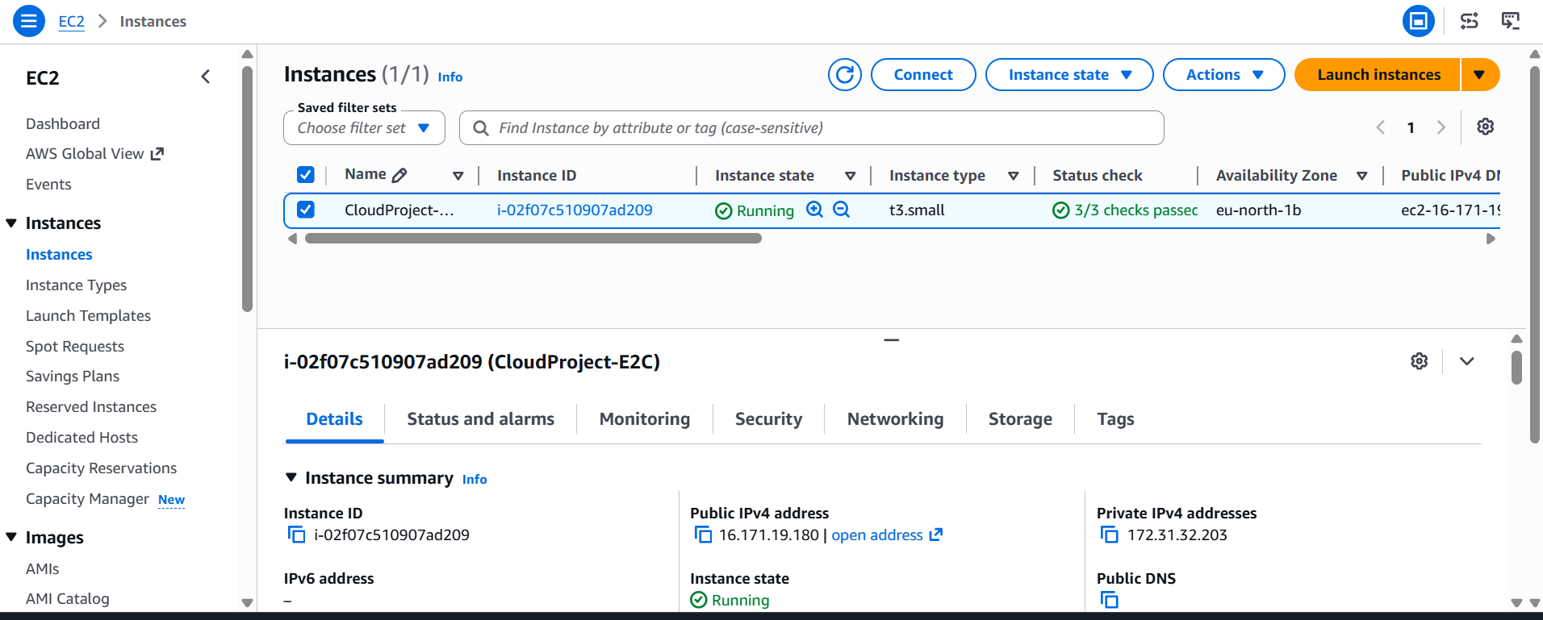
Components:
• User
• AWS Management Console
• EC2 Service
• Virtual Machine Instance
• Security Group
• Key Pair Authentication

Chapter 5: Implementation Procedures
Step 1: Launch EC2 Instance
An EC2 instance named CloudProject-EC2 was launched using Amazon Linux 2023 and the t3.micro instance type.
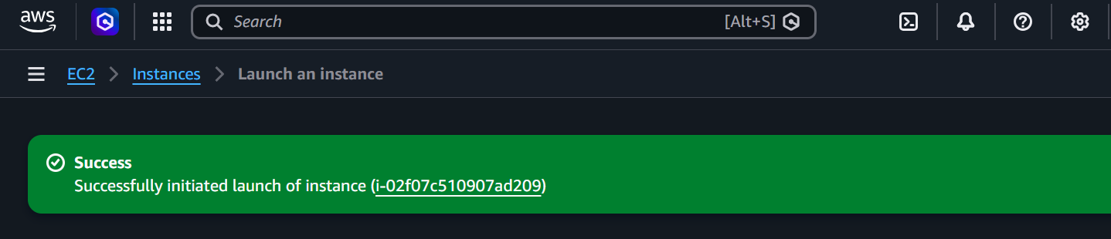
Step 2: Enable Termination Protection
Termination protection was enabled through Instance Settings.
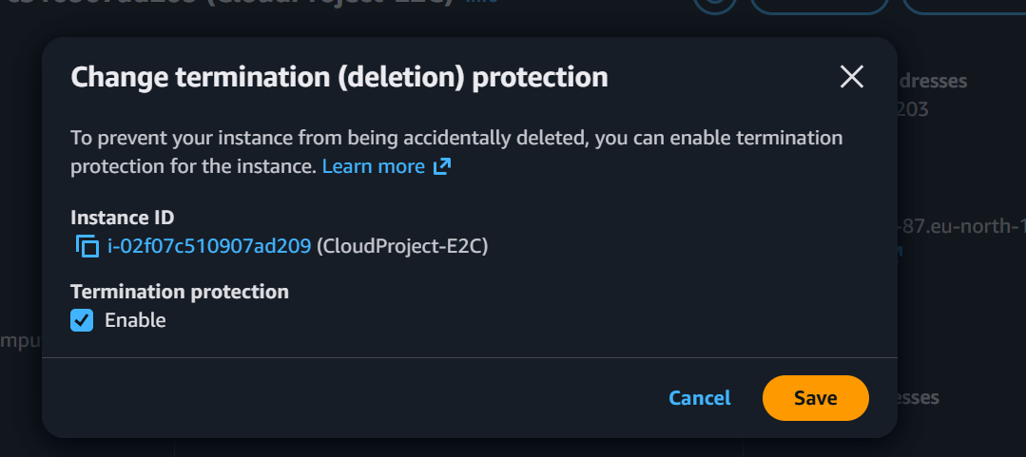

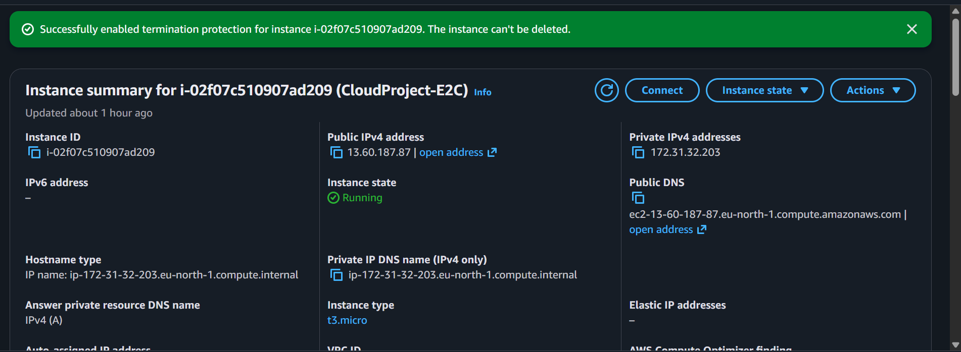 Step 3: Test Protection
A termination attempt was made. AWS prevented the operation and displayed an error message indicating that termination protection was active.
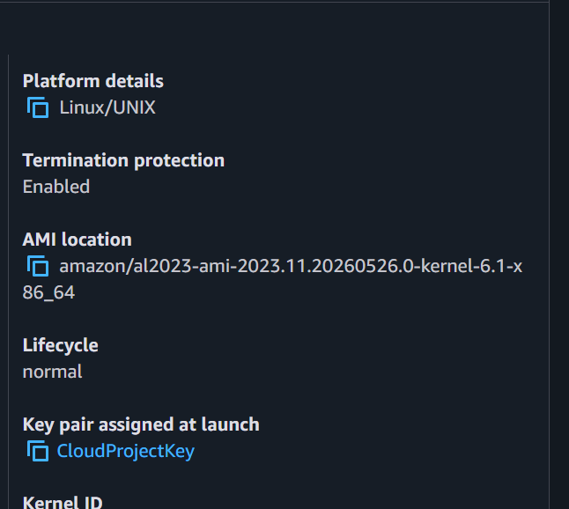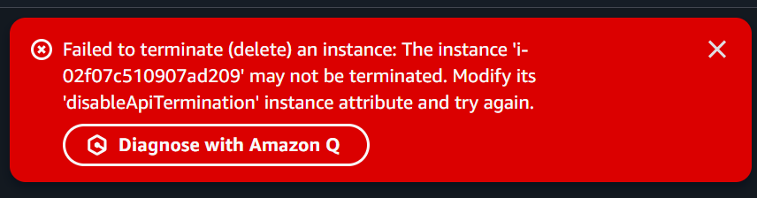
Step 4: Disable Protection
Protection was disabled to permit administrative changes.

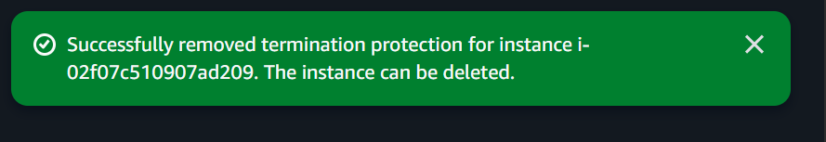
Step 5: Resize Instance
The instance was stopped and resized from t3.micro to a larger instance type such as t3.small.
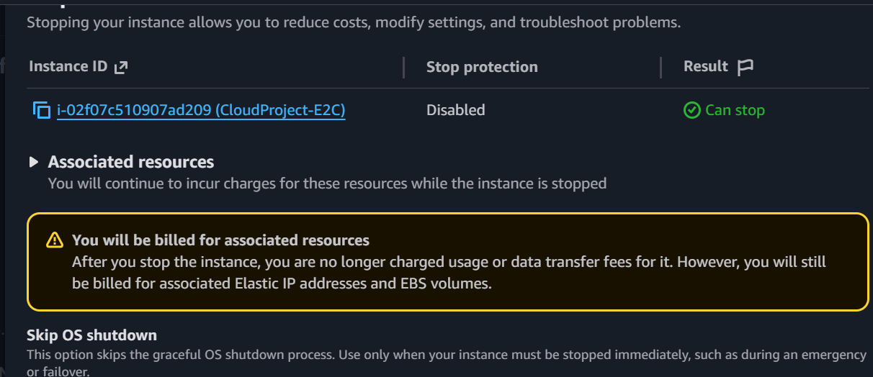
Step 6: Verification
The instance was restarted successfully and functionality was verified through EC2 Instance Connect.
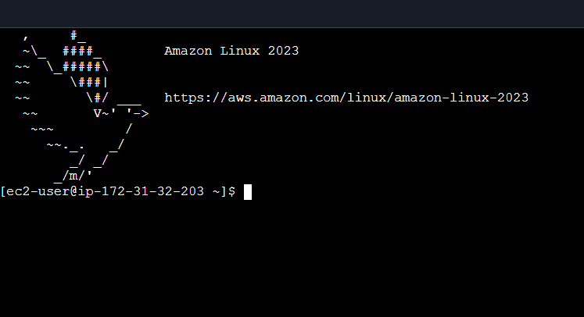

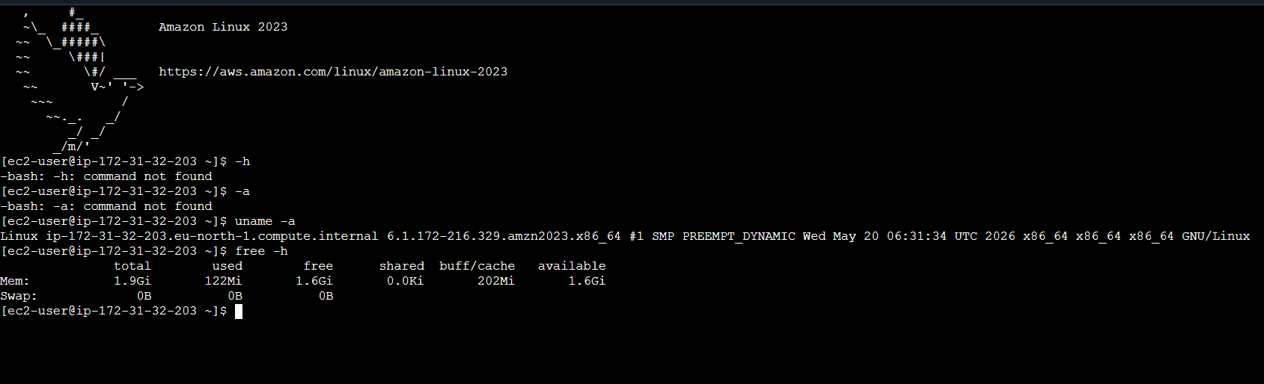

Chapter 6: Results and Discussion
The experiment demonstrated that termination protection effectively prevents accidental instance deletion. The resizing process was completed successfully without affecting stored data or system functionality.
Observed Results:
• Instance launched successfully.
• Protection enabled successfully.
• Termination blocked.
• Protection disabled successfully.
• Instance resized successfully.
• Instance restarted and verified.
Discussion:
The results demonstrate the reliability and flexibility of AWS cloud services. Organizations can safeguard critical infrastructure while adapting resource allocation according to workload requirements.

Chapter 7: Cost Analysis
AWS follows a pay-as-you-go pricing model. Smaller instances such as t2.micro incur lower operational costs but provide limited resources. Larger instances provide improved performance at increased cost.
Benefits of Cost Optimization:
• Avoid overprovisioning.
• Reduce operational expenses.
• Improve resource utilization.
• Scale according to demand.
Instance resizing supports cost optimization by enabling administrators to select the most appropriate resource configuration.


Chapter 8: Risk Assessment
Potential Risks:
1. Accidental termination of critical instances.
2. Incorrect resizing causing compatibility issues.
3. Insufficient permissions.
4. Security misconfigurations.
5. Unexpected service interruptions.
Mitigation Measures:
• Enable termination protection.
• Perform backups.
• Test changes in staging environments.
• Apply least-privilege access control.
• Monitor system performance.

Chapter 9: Benefits of the Project
Benefits of Termination Protection:
• Prevents accidental deletion.
• Improves availability.
• Enhances reliability.
• Protects production systems.
Benefits of Instance Resizing:
• Supports scalability.
• Improves performance.
• Optimizes costs.
• Adapts to workload fluctuations.

Challenges Encountered
Potential challenges include AWS account verification, service quotas, configuration complexity, network settings, and delays during instance state transitions. These challenges were addressed through proper planning and monitoring.

Chapter 10: Conclusion
The project successfully implemented EC2 termination protection and instance resizing within AWS. The results confirmed that termination protection safeguards cloud resources against accidental deletion while resizing enables efficient scaling and resource optimization. These features are essential for modern cloud infrastructure management and support reliability, scalability, and cost efficiency.

Recommendations
Organizations should:
• Enable termination protection for production systems.
• Conduct regular resource utilization reviews.
• Implement monitoring and alerting systems.
• Maintain regular backups.
• Follow AWS Well-Architected Framework recommendations.

References
Amazon Web Services. (2025). Amazon EC2 User Guide.
Amazon Web Services. (2025). AWS Well-Architected Framework.
Mell, P., & Grance, T. (2011). The NIST Definition of Cloud Computing.
Amazon Web Services Documentation.
Cloud Computing Design Patterns and Best Practices.

Appendices
Appendix A: AWS Account Creation Screenshots
Appendix B: EC2 Launch Screenshots
Appendix C: Termination Protection Screenshots
Appendix D: Instance Resizing Screenshots
Appendix E: Verification Screenshots
Note: Insert actual screenshots collected during implementation.

